MULLET CLASSIFICATION


1. Classic mullet: this specimen is a clear demonstration of a classic mullet. Note how this mullet proudly displays his exotic plumage while in a menacing stance. Classic indeed the mesh tank top, digital watch, silver chain, and molester moustache all add points to this fine specimen's overall look and mulletude.
Mulletude: 10
Aggressiveness: 10
Hobbies: football games, wife beating, and picking fights.
Sightings: everywhere, there's no escape (see: eyes).
Favourite Band: Steve Miller Band

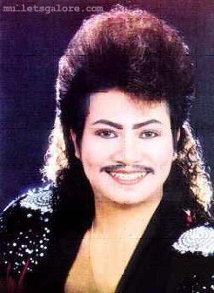
2. ???: Mary Mother of God make it stop.
Mulletude: 6-Aggressiveness: 9
Hobbies: freaking people out. Drawing mustachios.
Sightings: I don't want to know
Favourite Band: Morbid Angel


3. Trashmullet: trailer trash with a mullet. All that is needed to have a trash mullet is a trailer, some guns, a big-ass truck, a rebel flag, lots of mulletude, and no hair-care products. Some trashmullets think that they are gangsters. These trashmullets tend to manicure their mullet into a rat-tail. The rattailtrashmullets attire is different than the trashmullets, but the mulletude remains the same.
Mulletude: 10-Aggressiveness: 10
Hobbies: see the Harmony Corinna film, "Gumma."
Sightings: anywhere where there's wood paneling, lots of cats, and velvet paintings of Jesus.
Favourite Band: Krokus


4. Permullet: a mullet that has been specially treated with a permanent. This primping of the mullethead's plumage means that the subject takes great pride in his her lifestyle. The permullet tends to be a little less aggressive than his mullet counterparts, most likely because he she doesn't want to taint his mullet with the sweat that would be released in the process of kicking your ass.
Mulletude: 7-Aggressiveness: 5
Hobbies: spitting, cussing, and pissing.
Sightings: Monster truck rallies, wrestling events, in front of mirrors.
Favourite Band: Foreigner


5. Bowlet: quite simply a bowl-cut with a mullet added for spice. Don't be fooled by this creature’s gentle demeanour and humorous looks, they are considered extremely volatile.
Mulletude: 10-Aggressiveness: 10
Hobbies: Crack Rock, Rokken' Crack.
Sightings: Bars, locally owned fast food restaurants, and barns.
Favourite Band: The Eagles


6. Halfmullet: half of a half-assed haircut. This is the epitome of the mullet philosophy.
Mulletude: 0-Aggressiveness: 4
Hobbies: anal love beads.
Sightings: Germany.
Favourite Band: Scorpions


7. Skillet: this subspecies of mullet refuses to let go of his cherished plumage. Too many years of Pabst Blue Ribbon and 7-11 hookers have made this mullet confused and nonsensical. What isn't on top, he more than makes up for in the back. He keeps it in a ponytail for good luck and to keep the chicks hot.
Mulletude: 10 -Aggressiveness: 2
Hobbies: writing stupid stories about his shitty life while I don't have a scanner. Smelling like ass.
Sightings: San Francisco State University computer labs. Sitting in a ditch staring at the wall, mmmmhh. (See Sling Blade).
Favourite Band: Bad Company
Note: Nice tank top


8. Parental negligence/child abuse: aren't there laws written to prevent this kind of thing from ever happening? I can already see the mulletude being passed on. Sad, sad, sad...
Mulletude: 2 -Aggressiveness: 2
Hobbies: Goin' up in the fridge and gettin' dad a cold one. Playing with mommy's mullet.
Sightings: Slayer concerts, liquor stores.
Favourite Band: 311
Note: Avoid parents at all costs.

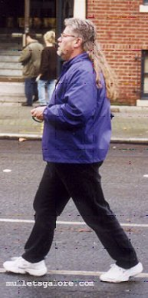
9. Grizzledmullet: Union worker. Pissed off. Nice mullet. A Very nice mullet. Looks as if some real time, effort, and nurturing went in the growth of this mullet. Fuck wage slavery.
This mullet was sent in by a lawyer from Seattle.
Mulletude: 8 -Aggressiveness: 5
Hobbies: maintaining his mane.
Sightings: The Midwest, Arena Rock Shows.
Favourite Band: Kenny Rogers.


10. Redrobinmullet: A subspecies of mulleticusrattailicusfeminis, the red robin mullet displays her vibrant mane when in search of a mate. Other times of the year, her mullet is drab and grey, but if you see one at the right time of the year, you're in for a treat.
Mulletude: 8-Aggressiveness: 6
Hobbies: power lunches, terminating employees.
Sightings: sushi bars.
Favourite Band: Styx.

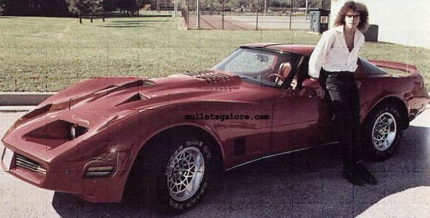
11. Not really a mullet, but a damn good picture.
Mulletude: 0
Aggressiveness: 8
Hobbies: impregnating 15 year olds, huffing gasoline.
Sightings: I wish I knew. I wish I knew.
Favourite Band: reo speedwagon.

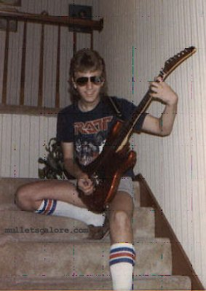
12. Nice: this is what everyone should look like when they're in their early teens. I have some glasses like that myself. I like to take them off really fast and stare someone in the eye while pointing my finger in their face and yelling about how they don't know what's really going on.
Mulletude: 2
Aggressiveness: 5
Hobbies: breakin' hearts, kickin' ass.
Sightings: suburbs.
Favourite Band: guess...
NOTE: tube soxxs rokk.

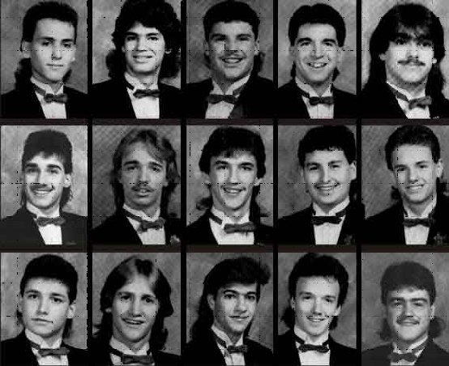
13. Mass-Mullet Contagion: Ladies and gentlemen, the future of America.
Note: I don't know, nor do I care what yearbook this came out of.


14. I don't know, I just think its funny.
Mulletude: 2
Aggressiveness: 1
Hobbies: celebrate the mullet, a mullet on da head.
Sightings: cold sore clinics, salons.
Favourite Band: live 105.

